**Website Document**

My website topic: Coffee

**Tesla**

<https://www.tesla.com/en_nz>

I like the use of large pictures and scroll features. There is always one whole picture taking up the screen. This is an element that I would like to incorporate into my website. On scroll features are also something that I would like to include. The tesla website has an on-scroll feature where if you scroll down, the website will jump to the next image so that it covers up the whole page. This is a good way to segment a website, this could also be done with card components. Research further.

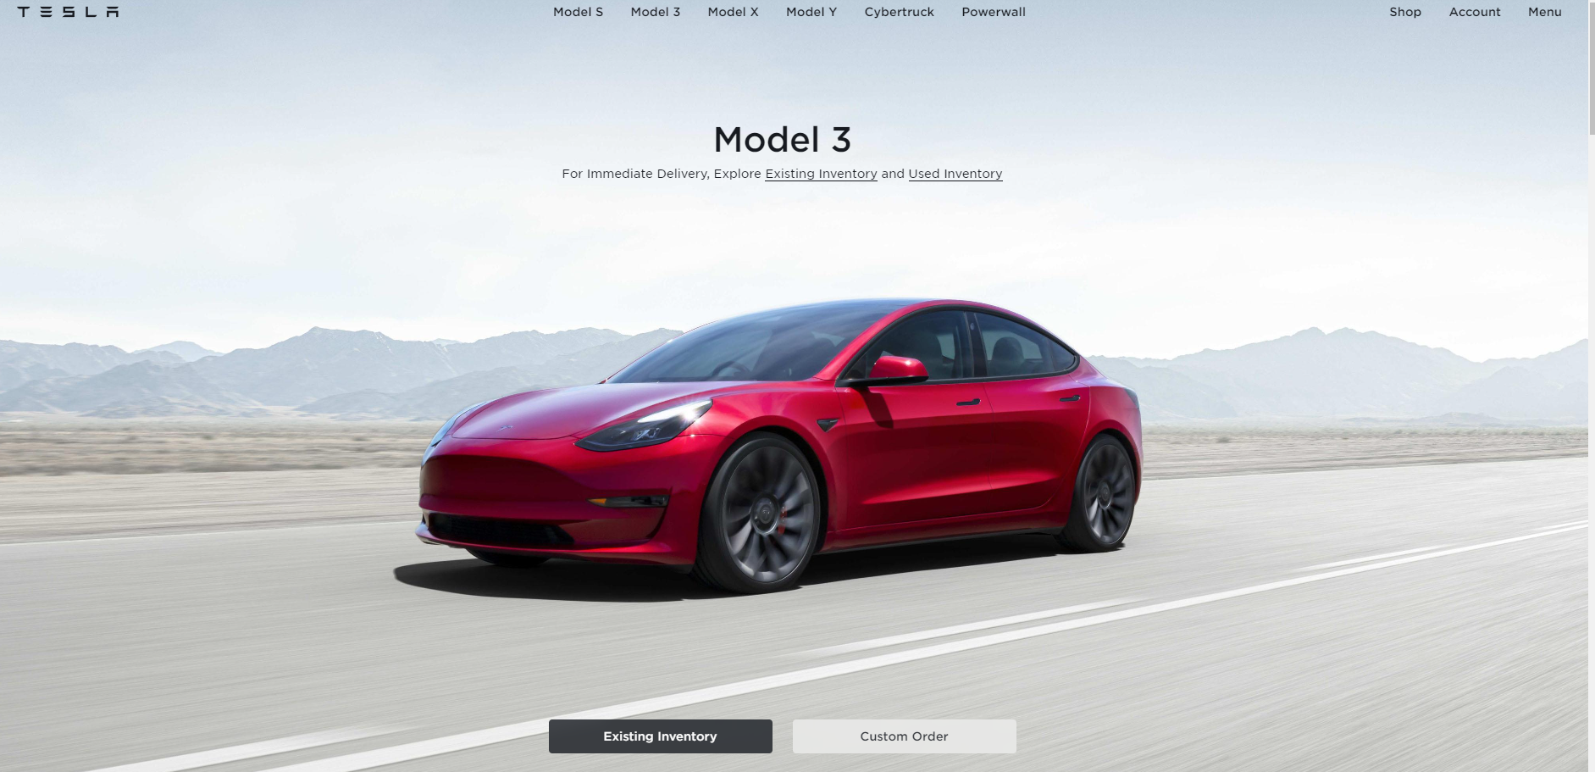

**Potion**

<https://www.sendpotion.com/>

I like the navigation style on the potion website. The floating nav bar centred at the top of the page and stays fixed throughout the scroll. Something I noted was that the colour of the nav bar stays the same, back due the background colour it changes between blending in and standing out.

**Verk**

<https://verk.se/>

The layout of the content of the Verk website is good. I like how the website displays information while still including large pictures. Also, the use of white space, or space that has no content is good. I would like to include how the text alternates side as you scroll down the page.

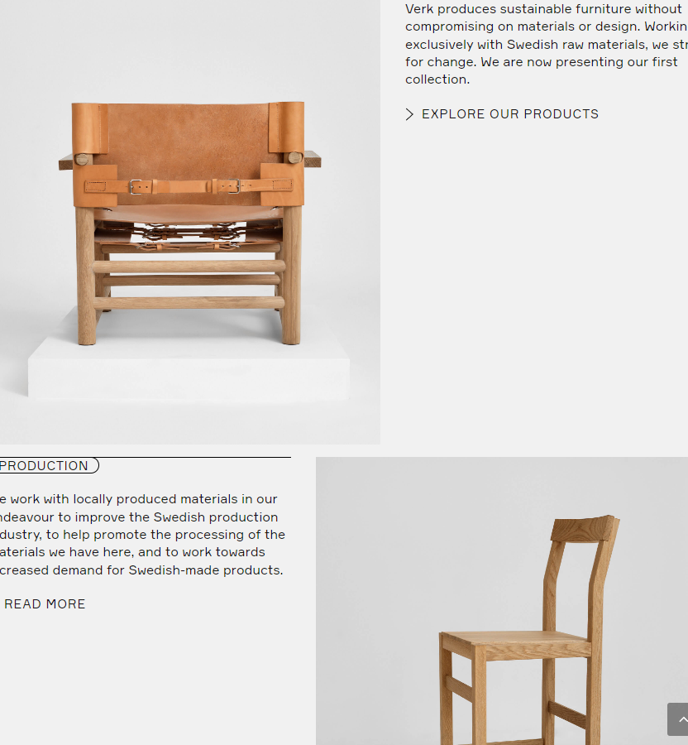

**Skydive Wanaka**

<https://www.skydivewanaka.com/skydive-gallery>

The skydive Wanaka website includes a gallery page. The pictures have hover features where they darken if you have an image selected. If you click on the image you also get a full size version in the form of a pop up. I think galleries on websites is a great idea to increase the amount of content on a website as well as looking better to the user. The Wanaka skydive gallery needs a bit of work. It looks like it struggles with images of different sizes. This has a few solutions: either ensure your images are all the same aspect ratio , or code the gallery to work with images of different sizes.

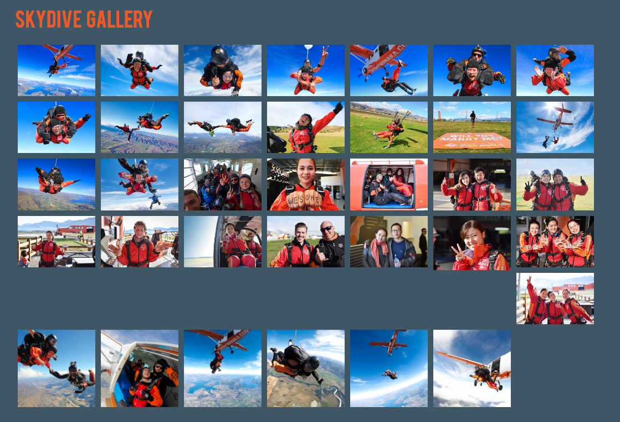 **Formula 1s**

<https://www.formula1.com/>

I look the hover effects on the cards on the right of the image below. The text box moves slightly and the image zooms. I like how these two effects are on the same component.

